Volt-ampere Characteristics of LED
Wangmeijuan
2013215109
2013213195
Measuring resistance by voltammeter is one of the basic methods. There is some relation between voltage and current while current passes through an element by adding voltage on it. The varying curve, gained by recording current as changing voltage, is called Volt-ampere characteristic curve. To follow the law of Volt-ampere characteristic curve, the electrical properties of a element is known. The resistance and Volt-ampere characteristic will be measured in this experiment.
1 Experiment principle
The circuit of measuring resistance by voltammeter is shown in Fig.1. According to the Ohm's law R_{X}=U/I, The unknown resistance can be calculated by measuring current I passing through resistor R_{X} and voltage.
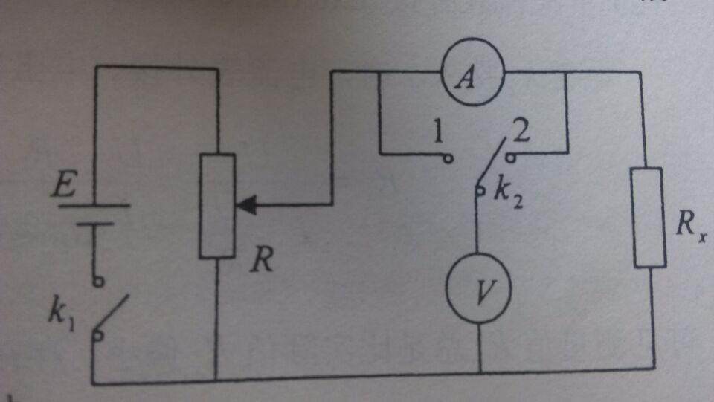
Fig. 1
1 Production and correction of system error
In actual measurement, no matter ammeter connected internally or externally ,system errors will be included in the final results as the introduction of ammeter and voltmeter(The internal resistance are R_{A} and R_{V} ). This kind of systematic error can be corrected.
(1)Internal ammeter
When K₂ switches to 1, ammeter is connected internally. The values shown by ammeter and voltmeter are I and U. Due to the Ohm's law:
R_{X}'=U/I=R_{X}+R_{A} 5-1
The measurement results R'_{X} are always slightly larger as the introduction of ammeter. While R_{X}>>RA, the measurement error introduced by internal ammeter is small, then RA can be ignored. With the correction formula
RX=U/I-RA=RX'-RA 5-2
the effect of ammeter internal resistance is eliminated.
(2) External ammeter
When k2 switches to 2, ammeter is connected externally. The values shown by ammeter and voltmeter and I and U. Due to the Ohm's law:
Rx=U/(I-U/RV)=(U/I)(RV/(RV-U/I))=RX'(RV/(RV-RX')) 5-3
The measurement results Rx' are always slightly smaller. While Rx<<Rv, the measurement error introduced by external ammeter is small, then Rv can be ignored. Formula 3 can be used to eliminate the effect of voltmeter internal resistance.
2. Effect Of Meter
Instrument error of a meter is Grade % timing range so that the grade and range of a meter will affect measurement results directly. When the grade is fixed ,instrument error will become larger as increasing range. For example, to measure a voltage around 4V with a voltmeter with grade 0.5, if using range 5V and 10V respectively, the instrument errors are shown as following accordingly.
Range5V: Deviation =0.5%*5=0.025V
Range10V: Deviation=0.5%*10=0.05v
To reduce the error, the proper range should be chosen. Generally, the measured value should be between 1/2~2/3 of range
3. Introduction of LED
Alight emitting diode(LED) is essentially a pn junction diode typically from a direct bandgap semiconductor. The emitted photon energy is approximation equal to the bandgap energy, hv=Eg=eU₀ where Eg is the bandgap energy. By measuring the volt-ampere characteristic curve of LED ,threshold voltage Uo can be fund.
The energy of an emitted photon from an LED is not simply equal to the bandgap energy Eg because electrons in the conduction band are distributed in energy and so are the holes in the valence band. The minimum emitted photon energy from heavily doped semiconductors is therefore less then Eg and depends on the amount of doping.
2.Experiment
In the experiment ,we will measure the volt-ampere characteristic curves of a LED.
Choose the ranges of the voltmeter and ammeter according to the requirements. The selection of measuring points should be proper. In the lo voltage the measurement points should be loose and in the upper voltage the step should be tight .There is warning that the current shouldn't exceed 10mA.
3.Result
